|  |  |  |  |  |  |
| --- | --- | --- | --- | --- | --- |
| To | Florida Turnpike Enterprise | |  | Pages | 19 |
| CC |  | | | | |
| Subject | CFRPM 6.1 Updates for Orlando South Project | | | | |
|  |  | |  |  | |
| From | Hongbo Chi (AECOM), Chunyu Lu (AECOM) | | | | |
| Date | July 10th, 2017 |  | | | |

AECOM are the project team retained by the Florida Turnpike to update the latest Central Florida Regional Planning Model 6.1 (CFRPM 6.1) for the subsequent refined subarea analysis. Florida Turnpike requests the model updates for three scenarios, namely 2015, 2025 and 2045. The modeling team performed the following steps for the request:

* Updated the Highway network to include necessary local road links (2015, 2025 and 2045);
* Updated the land-use data for the corresponding three scenarios;
* Adjusted the free flow speed value for I-4 within Orange County;
* Updated the toll rate for the toll road within the study area;
* Double checked traffic count station locations and combined the 2015 observed traffic counts to the highway network;
* Updated the model parameters;

This memorandum summarizes the update work in details.

# Subarea Definition

The subarea is defined by Florida Turnpike as Figure 1. Most of the effort AECOM team committed is within this region.

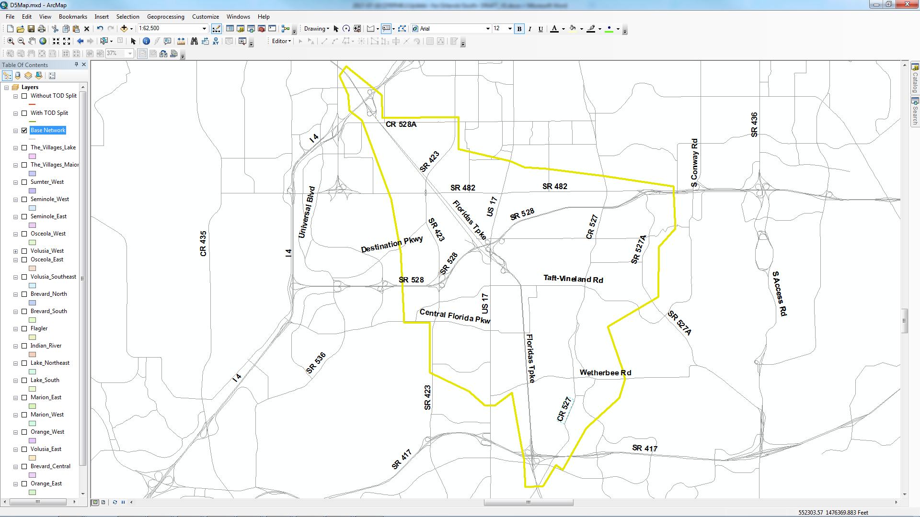

Figure : Subarea Definition

# Highway Network Updates

For the purpose of the subarea analysis, some new links were added to the highway network. In addition, two TAZs were split, so additional centroid connectors were also added into the network. Three new zones are added to the network, which are 1094, 1095 and 1096. The updates were implemented in the networks of 2015, 2025 and 2045. The following Figure 2 and Table 1 summarize the network updates. Besides the updates on the highway networks, the corresponding transit network files also got updated to exactly match with the highway network.

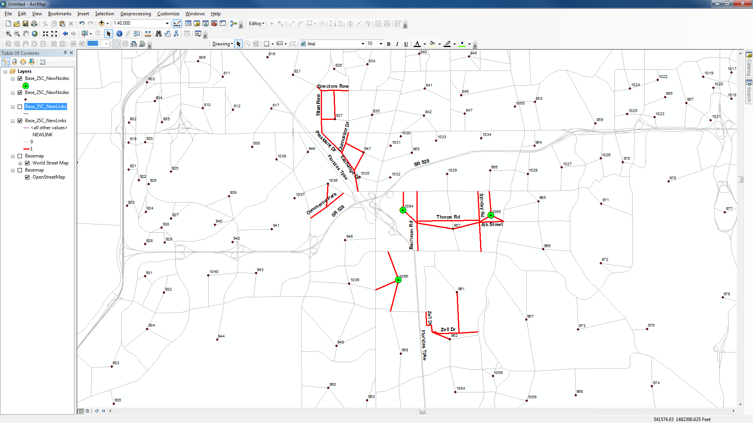

Figure : Network updates

Table Table 1 New road links (for all three scenarios)

|  |  |  |
| --- | --- | --- |
| Road Name | Lane number | Speed limits (mph) |
| Directors Row | 2 | 35 |
| Titan row | 2 | 40 |
| Presidents Dr. | 2 | 40 |
| Exchange Dr. | 2 | 40 |
| Chancellor Dr. | 2 | 35 |
| Commerce Park Dr. | 2 | 35 |
| Bachman Rd. | 2 | 40 |
| Thorpe Rd. | 2 | 40 |
| Sidney Hayes Rd. | 2 | 40 |
| Zell Dr. | 2 | 40 |
| 4th Street | 2 | 40 |
| 827 Centroid Connectors | 2 | 18 |
| 947 Centroid Connector | 2 | 18 |
| 1036 Centroid Connector | 2 | 18 |
| 961 Centroid Connector | 2 | 18 |
| 962 Centroid Connector | 2 | 18 |
| 1094 Centroid Connector | 2 | 18 |
| 1095 Centroid Connector | 2 | 18 |
| 1096 Centroid Connector | 2 | 18 |

# Land-use Data Update

For the subarea, AECOM team updated the Socio-Economic data for the three scenarios. Two zdata files, namely, ZDATA1_{Year}C.dbf and ZDATA2_{Year}C.dbf were updated accordingly for each scenarios.

# Toll Rate Updates

According to the 2015 SunPass toll rates from TEAR Report provided by Florida Turnpike, the toll rates in the highway network were updated accordingly for the Northern Coins and Beachline within/close to the study area. It should be noted that CFRPM 6.1 does not support the toll ticket system, so the toll rates from ticket system are not included in the update works on the highway networks. The following Table 2 shows the updates on the toll links.

Table Toll rates updates

|  |  |  |
| --- | --- | --- |
| **Toll Road** | **Mile Post - Toll Location** | **Toll updates** |
| Florida’s Turnpike | 240 - Kissimmee Park Road | Update to $1.32 from $1.00 |
| 244 - Kissimmee-St. Cloud North | Update to $1.32 from $1.25 |
| 249 - Osceola Parkway | Update to $1.06 from $1.00 |
| 251 - SR 417 | Update to $0.79 (New Interchange) |
| 255 - Consulate Drive | Update to $0.79 from $0.50 |
| 259 - Orlando (I-4) | Update to $0.53 from $0.50 |
| 272 - Winter Garden | Update to $0.53 from $0.50 |
| SR 528 | 6 - MAINLINE PLAZA | Update to $0.79 from $0.75 |

# Speed Limit Update

Within the Orange County, the free flow speed of I4 was 62.5 mph, which is considered to be high, and causes I4 attract too many traffic from the local road. The free flow speed value is therefore decreased by 5 mph in the I4 within Orange County.

# Observed Traffic Count Update

Since year 2010 is the base year for the CFRPM 6.1, all the observed traffic counts are 2010 based in the CFRPM network links. The observed traffic counts in the subarea are updated to 2015 based on traffic information from FTI and from Florida Turnpike (Northern Coin and SR 528). Before the traffic count updates, some sanity checks were performed on the 2010 traffic count in the network. There are potentially four major issues on the 2010 traffic count as followings:

* Some traffic count locations are not correct.
* Some traffic counts were not coded on the network.
* The traffic counts are AADTs, which should be factored by peak season factors in order to perform a fair comparison with the assigned traffic volume (CFRPM model is a peak-season based model).
* The traffic count should be balanced.

Appendix A1 shows the comparison between the original 2010 observed daily traffic count with 2010 daily assigned traffic volume. It can be seen that traffic counts are missing from three count stations and the overall V/C ratio is 1.32.

In Appendix A2, the wrong count locations were corrected and the missing counts were refilled. The overall V/C ratio is dropped to 1.26.

In Appendix A3, the traffic counts were factored by a peak-season factor of 0.94, in the meantime, the I4 speed limit is increased by 5 mph. the overall V/C ratio is 1.14.

In a similar way, the following four steps are performed to update the traffic count to 2015:

* Double confirm the 2015 count and detector location based on the FTI online tool (http://flto.dot.state.fl.us/website/FloridaTrafficOnline/viewer.html).
* Balanced the 2015 traffic count in the SR 528 and North Coin.
* Factored the daily traffic count into 4 time period based on hourly traffic count information (AM: 6:30AM~9:00AM, MD: 9:00AM~3:30PM, PM: 3:30PM~6:30PM, NT: 6:30PM~6:30AM).
* Apply the peak-season factor during the comparison

# Model Parameter Updates

With the careful check, the modeling team identified the three following potential issue for the CFRPM model:

* The value of capacity factors for the 4 period is too high
* UROADFACTOR is too low
* S. John PKWY’s facility type near the study area is not correct

The modeling team did the following updates accordingly

* Changed the capacity factor as the following Table 3 show;
* Directly borrowed UROAD factor from SERPM 7;
* Updated S. John Young’s facility type to 23 from 21.

Table Time-of-day capacity factor updates

|  |  |  |
| --- | --- | --- |
| **TOD capacity factor** | **Original Value** | **Updated value** |
| AMCAPFAC | 2.5 | 2.0 |
| MDCAPFAC | 6.0 | 4.5 |
| PMCAPFAC | 3.0 | 2.5 |
| NTCAPFAC | 10.0 | 4.0 |

With the above updates, the tables in Appendix B illustrate the final V/C ratio comparison for Daily and 4 TOD periods. According to the tables in Appendix B, the updated CFRPM model for year 2015 can achieve V/C ratio of 1.08 for Daily, 1.03 for AM period, 1.13 for MD period, 1.04 for PM period and 0.97 for NT period.

# Summary

This technical memo summarizes the efforts of AECOM team on the CFRPM 6.1 updates for the purpose of subarea analysis. Through the updates in 6 aspects, namely, network, land use, speed limit, toll rate and traffic count, and model parameter updates, the updated CFRPM 6.1 model finally can achieves of overall daily V/C ratio of 1.08 for Year 2015 in the study area, which is a significant improvement compared with the daily V/C ratio of 1.32 for Year 2010 in the original CFRPM model in the study area.

**Appendix A-1 Daily Volume Count Comparison for the Year 2010 from Original CFRPM Model**



**Appendix A-2 Daily Volume Count Comparison for the Year 2010 from CFRPM Model with Updated Traffic Count**



**Appendix A-3 Daily Volume Count Comparison for the Year 2010 from Original CFRPM model with Implementation of Peak-Season Factor and I4 Speed Limit Updates**



**Appendix B-1 Daily Volume Count Comparison for the Year 2015 from Updated CFRPM Model**





**Appendix B-2 AM Volume Count Comparison for the Year 2015 from the Updated CFRPM Model**





**Appendix B-3 MD Volume Count Comparison for the Year 2015 from the Updated CFRPM Model**





**Appendix B-4 PM volume Count Comparison for the Year 2015 from the Updated CFRPM Model**





**Appendix B-5 NT Volume Count Comparison for the Year 2015 from the Updated CFRPM model**



